**CSE5325-005**

**Bonus Class Assignment: Software Tools and Practices**

TEAM 11

Rohit Sharma (1002167374)

Akarsh Jana (1002124308)

Version Control:

1. Repository Setup-

Repository “SE2_Team11” Created.

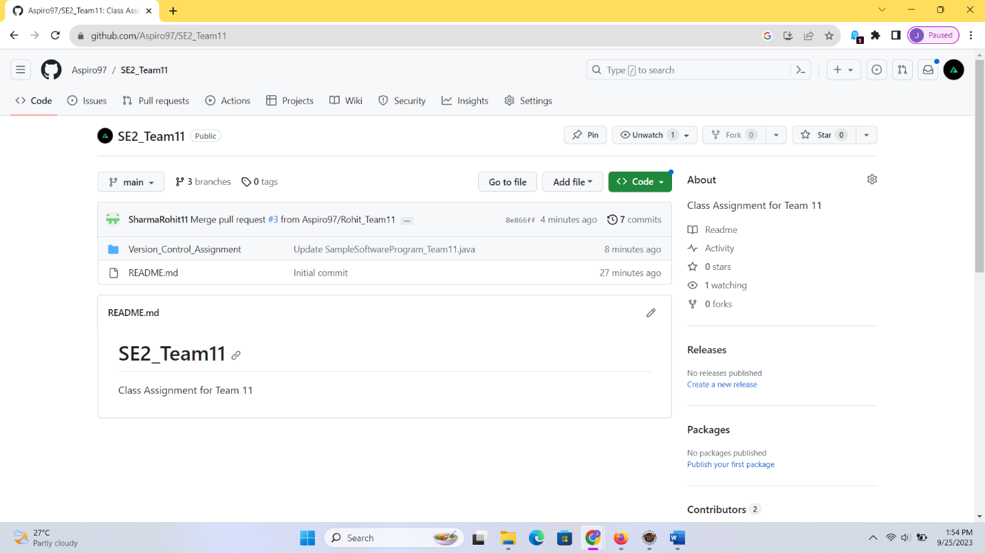

Initial Commit Done: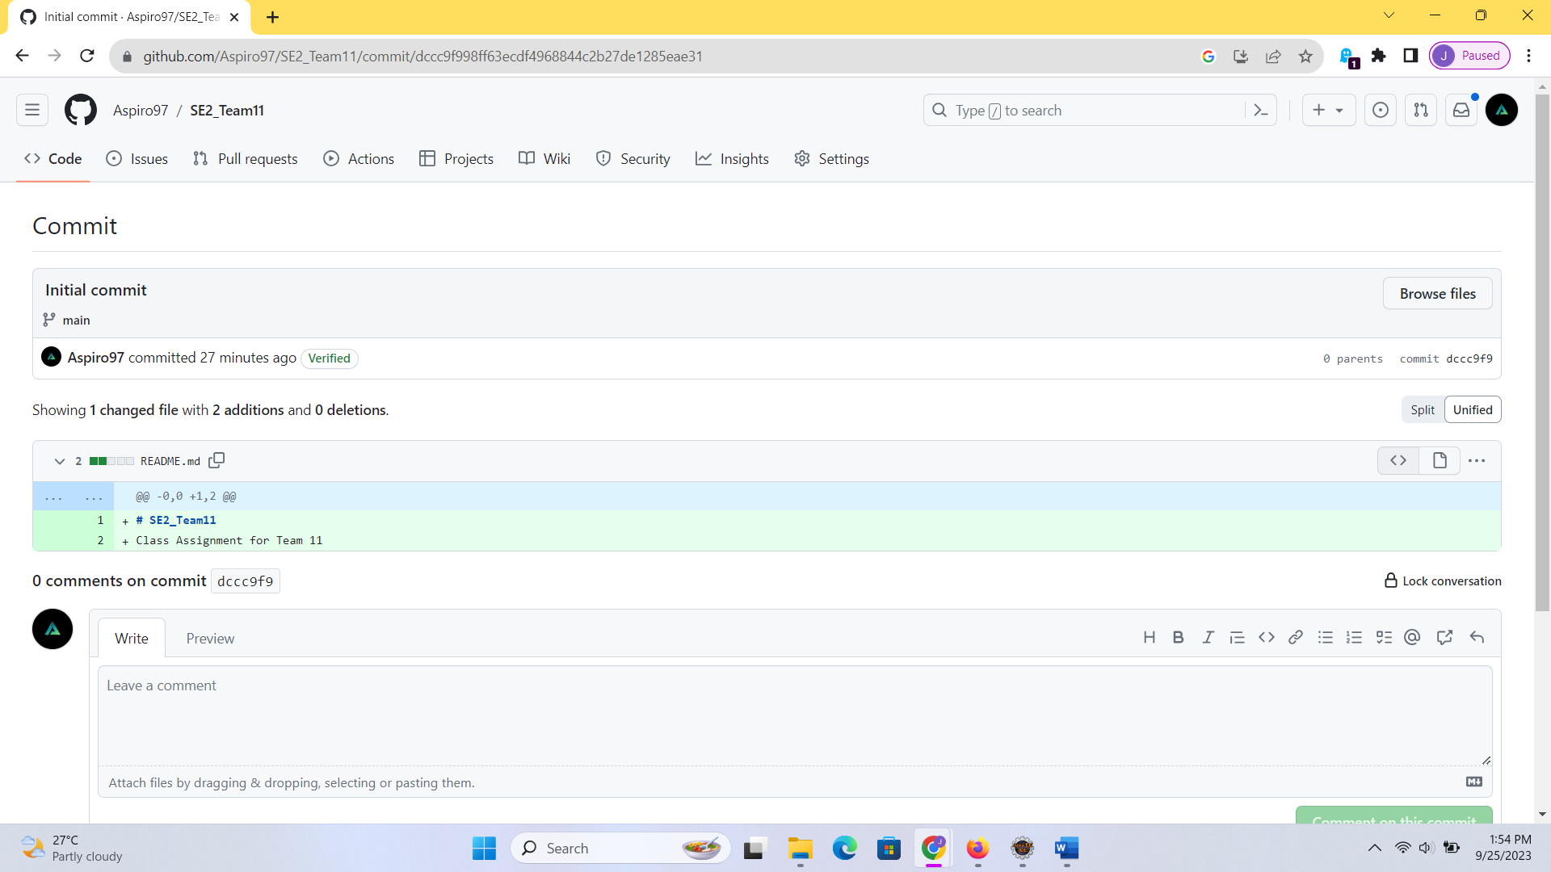

1. Branching and Merging:

Different branches Created.

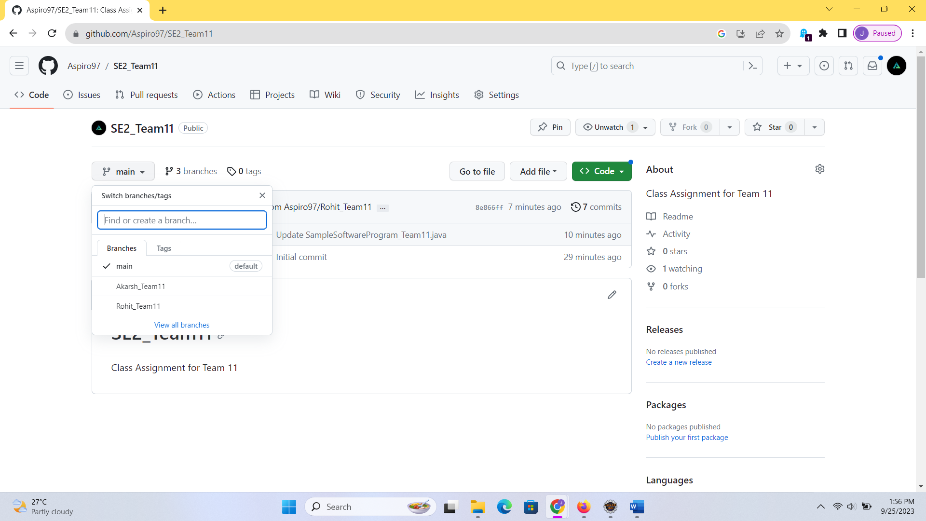

Code changes done into Branch “Akarsh_Team11”

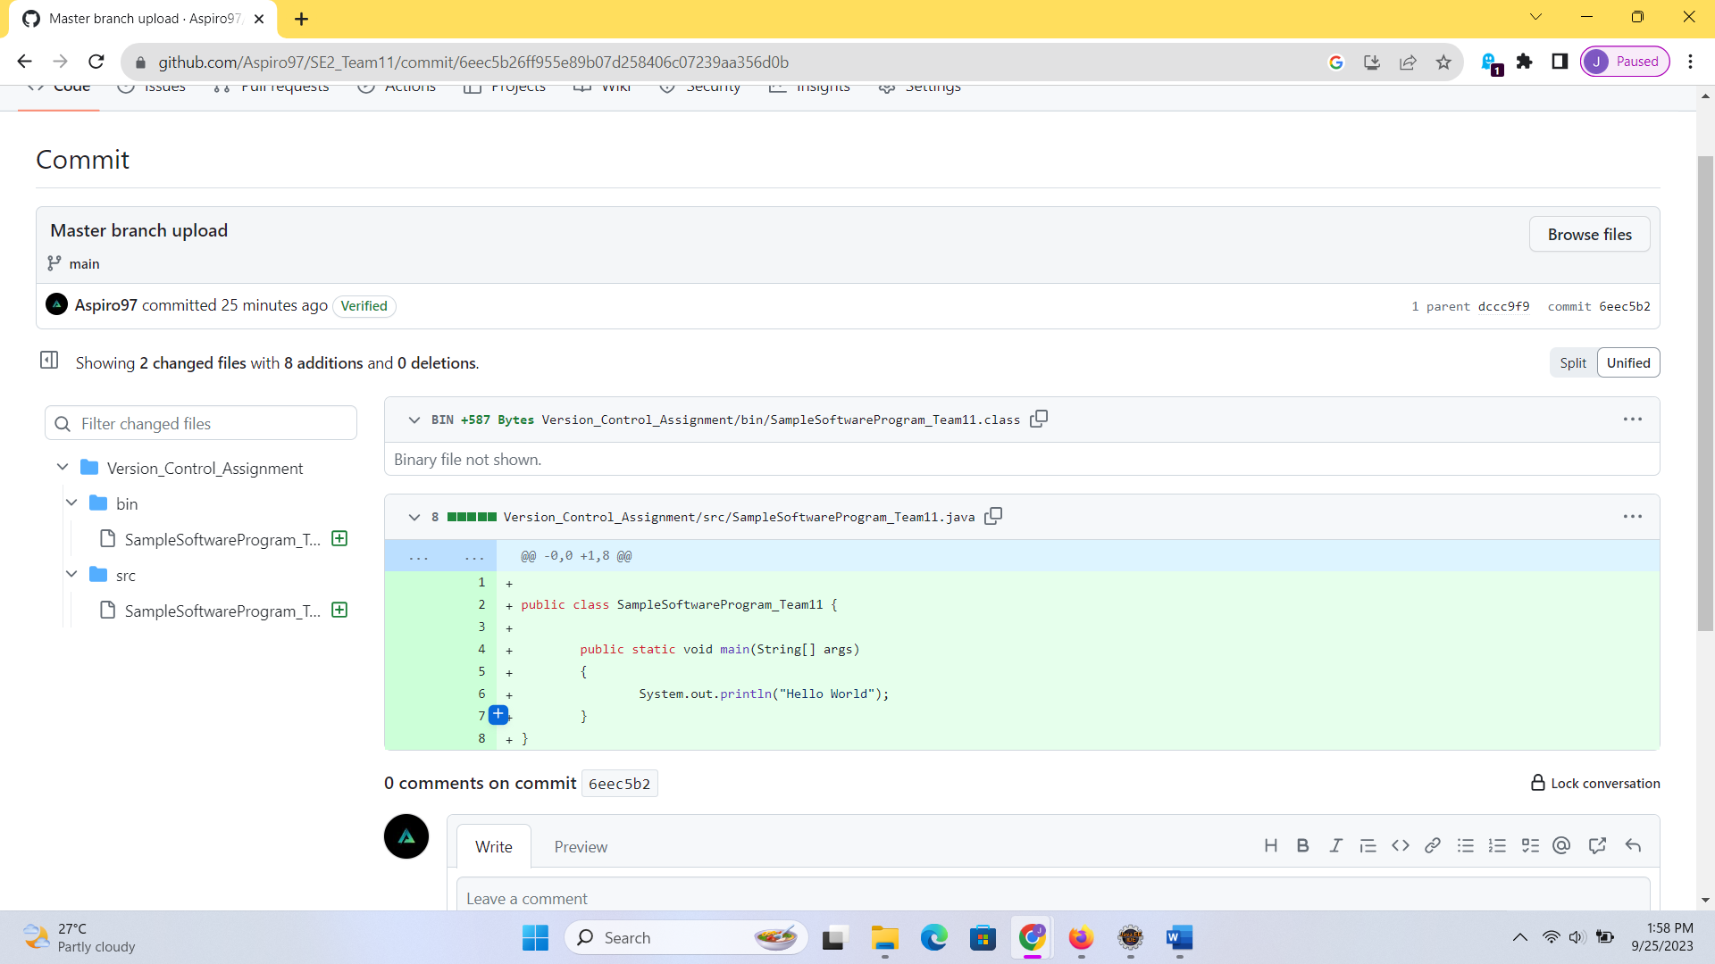

Changes Merged to “main” branch using Pull Request (Merging).

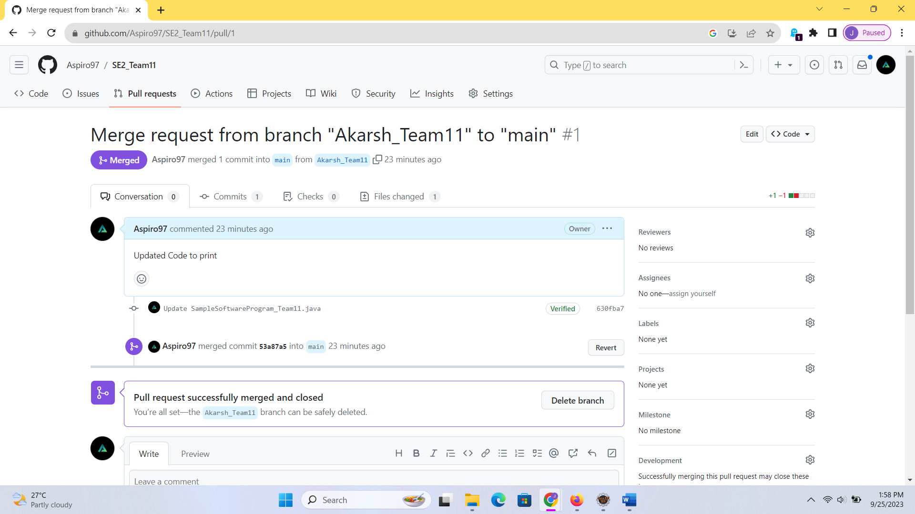

1. Collaboration.

Teammate invited for collaboration onto the repository.

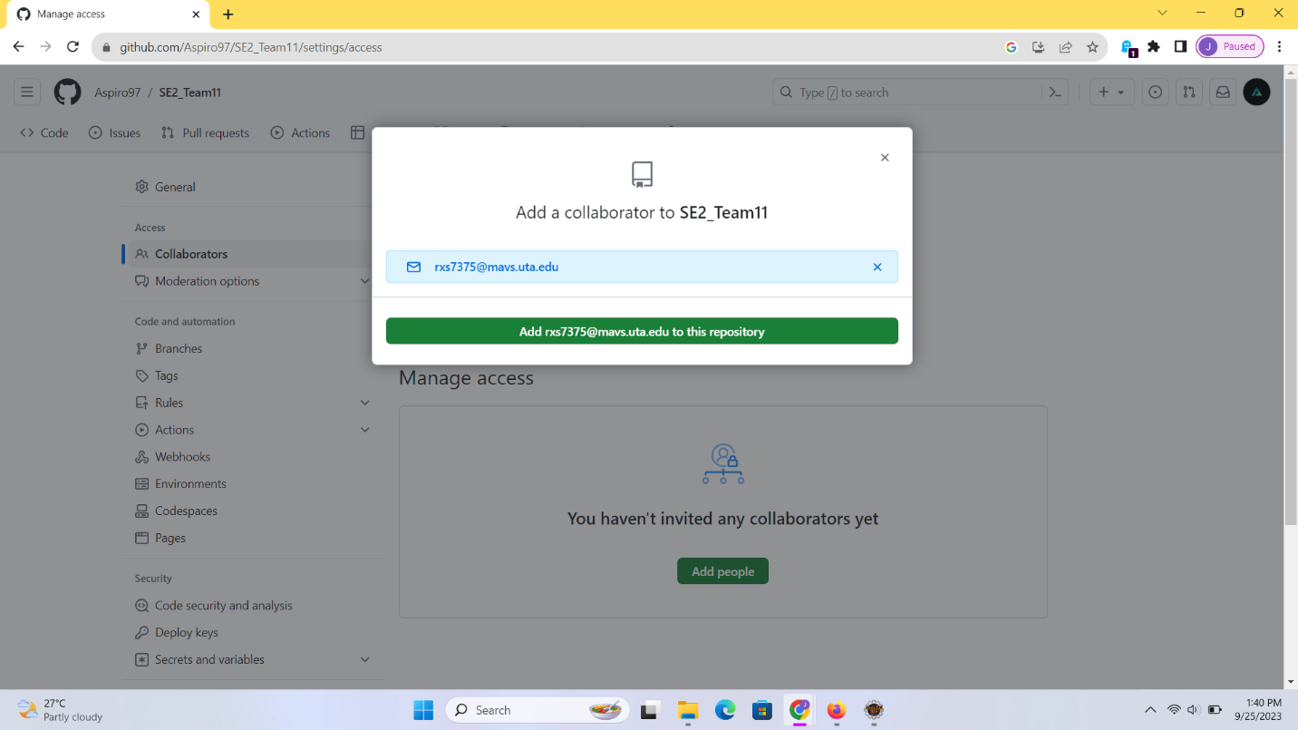

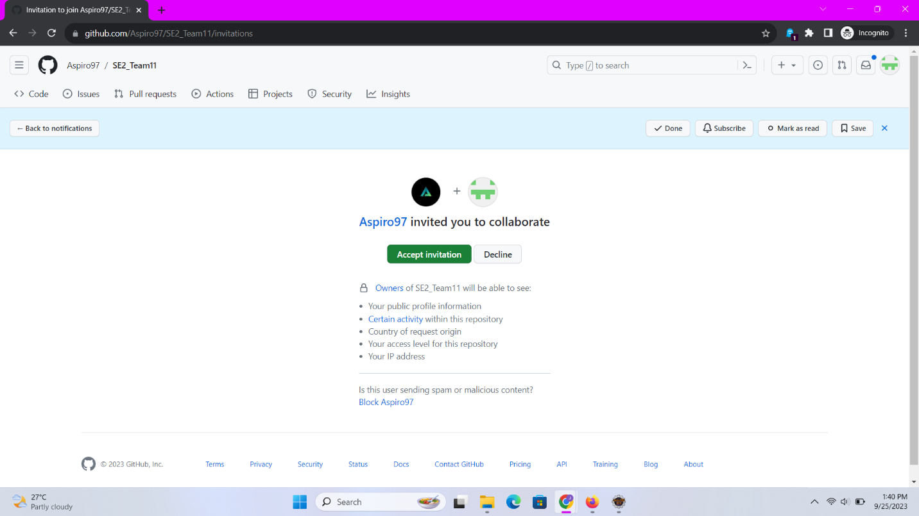

Teammates branch – “Rohit_Team11”

Code changes done into branch “Rohit_Team11”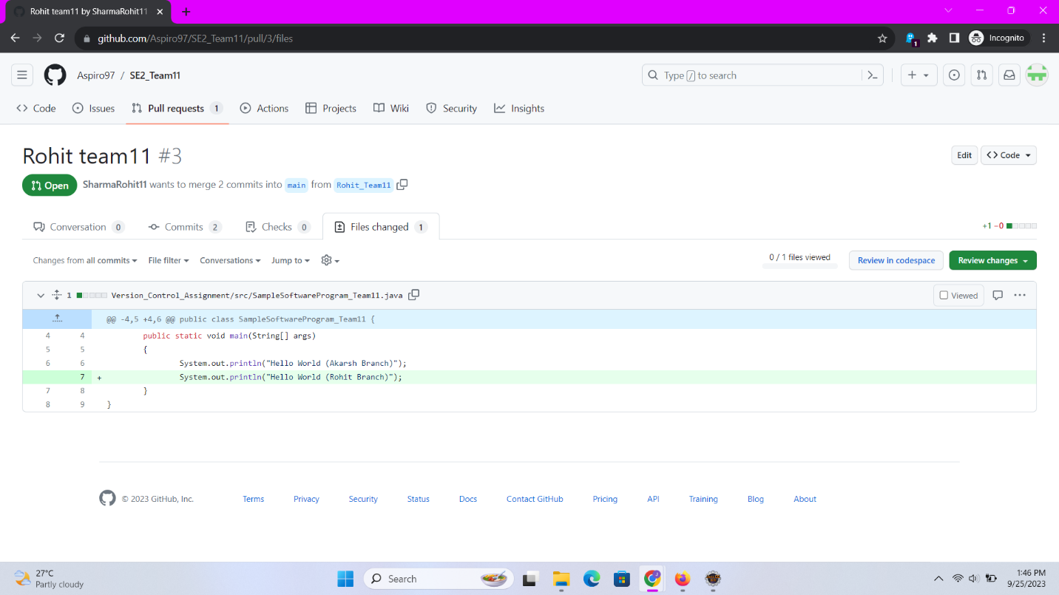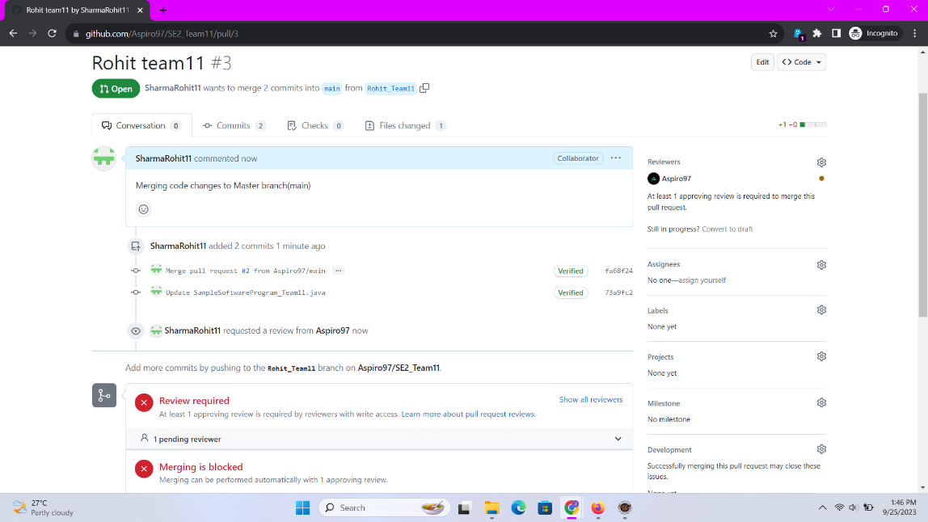

Requesting Code Review from Owner: 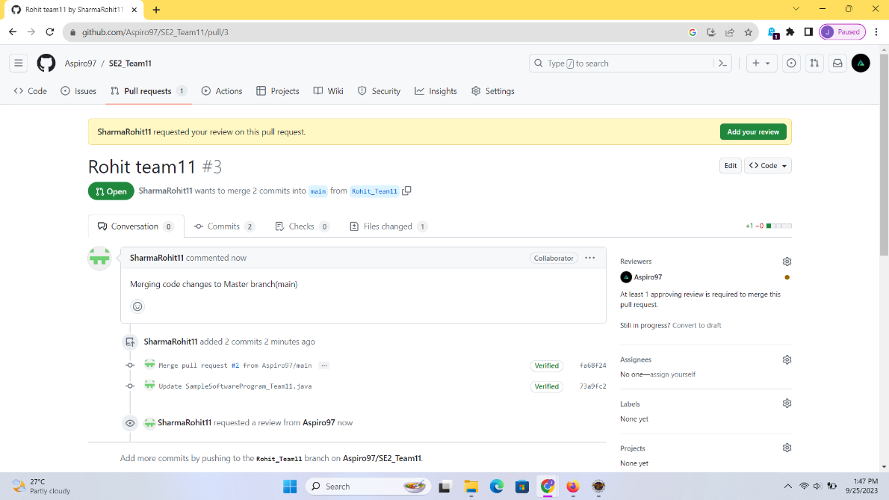

Adding Review and comments: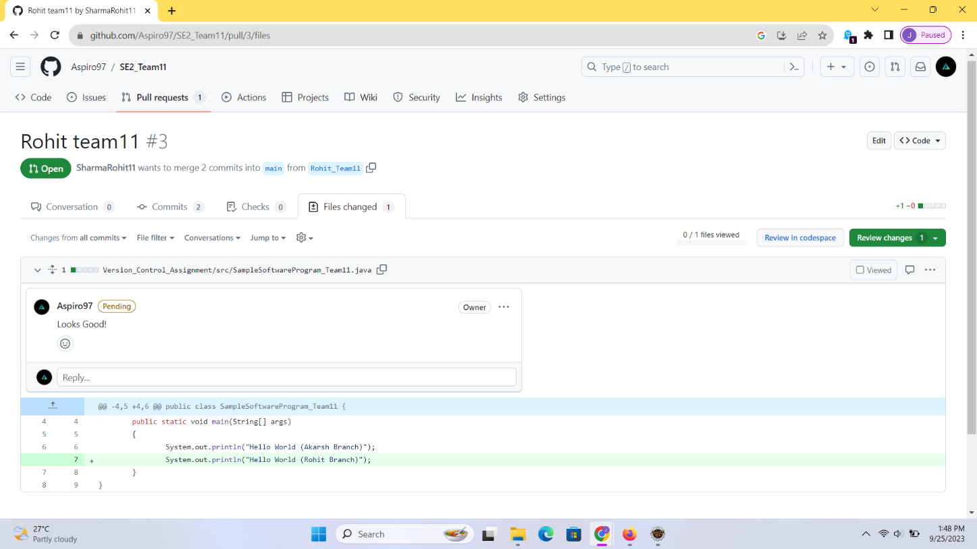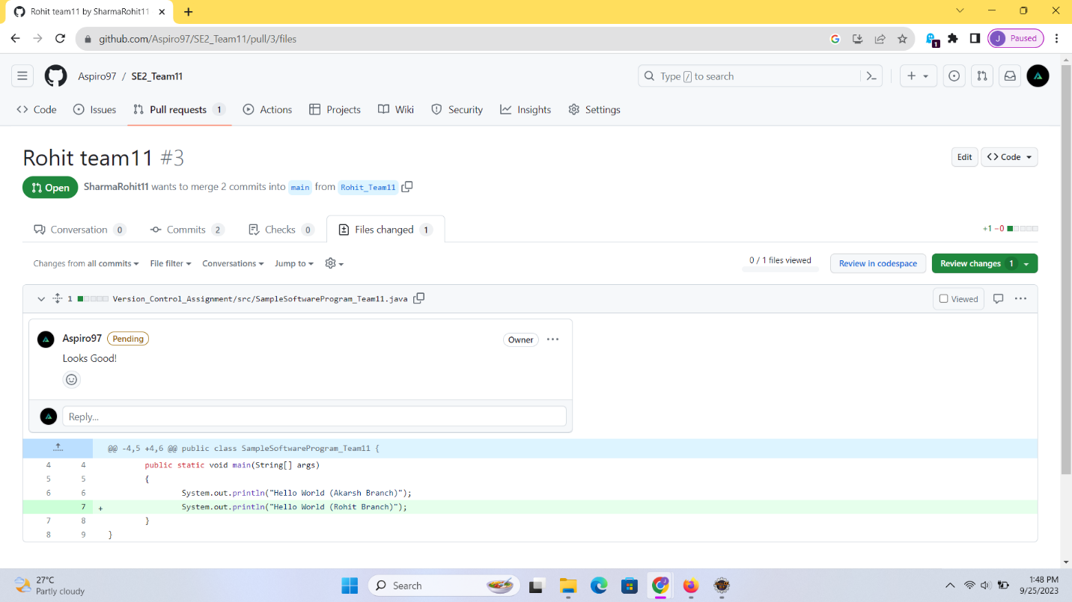

Review Done and now merging changes from branch “Rohit_Team11”